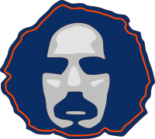
YOUSSEF FALTAS
creative web developer

I design and develop simple clean responsive websites with a twist of creative coding
www.faltastic.github.io/hello/
youssef.faltas@gmail.com

EDUCATION University of Florida, Gainesville, Florida, USA

MSc in Physics, 2008
BSc in Physics and Astronomy, Summa Cum Laude, 2006

EXPERIENCE Web Designer + Developer 2012 -current

A Dictionary of the Revolution (2017)
Visualization of the inter-connections between new words that entered political dialogue following the January 2011 revolution in Egypt

Syria on the Move (2016)
A photomapping web app which gives a voice to Syrians in exile by enabling them to communicate with others through photography

Thrust EG (2015)
Website of a company working as a Human Development and Learning catalyst

Agnes Michalczyk (2014)
Artist portfolio of Agnes Michalczyk

TOOLS
Web

HTML + CSS
PHP
Javascript

Foundation
Bootstrap

Wordpress
Joomla
Creative Coding

Processing
Arduino
Cinder

OpenCV

Python

p5.js, threejs
Graphics

- Adobe -
Photoshop
Illustrator
AfterEffects

Inkscape
Gimp

